Research

GENRE

Genre shares an etymological root with the Latin genus, meaning ‘kind or class of things’. Genre coming from France meaning ‘Kind, sort, style’.

Genre can be classified and recognised by conventions through a ‘collection of formal devices’. These can be plot elements like that of an investigation in a crime drama (The Godfather), thematic elements; ‘general meanings that are summoned up again and again’, characteristic film techniques such as chiaroscuro in a film noir (Psycho) and iconography as well as setting and symbolic images such as a gun for a crime drama or outer space for a sci-fi. Films classified by iconographic imagery are broadly associated with genres (such as western, science fiction, crime or adventure) where setting and objects are easily recognisable. However, some genres are not directly related to visual cues, like a comedy or romance.
In addition, when these cues are intermingled they can create ‘hybrid’ or subgenres that become more complex and include aspects of two or more genres. Despite, for the most part, subgenres being recognised as part of the ‘postmodernist movement’, the intermingling of genre had been seen from as early as 1935 from The Phantom Empire, combining western, sci-fi and musical. Most commonly however, there are ‘hybrids’ that are seen in twentieth century and new Hollywood film that shaped our understanding of subgenres that created a basis for filmmakers in modern Hollywood. Stanley Kubrick’s Full Metal Jacket (1987) mixed drama, action, and history, Steven Spielberg’s classic, Jaws (1975) plays with comedy, horror, drama, mystery and adventure through the use of unknown threats, fast paced action and parodic moments like that of ‘You’re gonna need a bigger boat’ before disaster. Being influential directors, their films have been a foundation for new filmmakers of the twentieth century, and ‘hybrids’ are now vastly seen across all Hollywood cinema. Directors like Edgar Wright mix many genres within each film. With a budget of 34 million, Baby Driver made 226.9 million at the box office taking on action, comedy and crime, Hot Fuzz (2007) intermingles complete opposites on the genre spectrum with drama and parody, Shaun of the dead (2004) mixes fantasy, horror and comedy. The vast array of differences between each film created from a single director shows the development of genre experimentation and the audience expectation in the modern era.

History of Genre and Subgenres

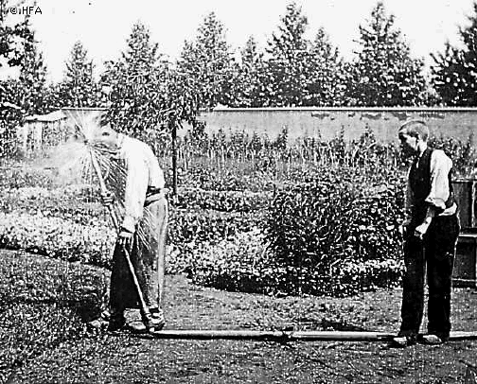
The Lumiere Brothers invented and patented the ‘Cinematographe’ in 1895 which enabled groups of people to enjoy cinema by projection; one of their first films was called The Sprinkler Sprinkled.

It was the first comedy ever made by use of physical humour. One of films ‘largest goals’ at the time was to produce entertainment through the use of comedy as film could easily be conveyed through visual action and physical humour called ‘slapstick’ using over exaggerated movements and absurd situations; many comedians were icons for this type like Buster Keaton and Charlie Chaplin. With the coming of sound however, Comedy changed in the 1930’s to be more reliant on comedic dialogue and developed into a ‘satirical tool’. The first comedy subgenre was the ‘screwball’ continuing to develop in the 30’s using ‘social satire’ that often took an ‘anarchic tone’ or ‘irreverent view’. This approach to comedy seems aggressive and daring as audiences before were only exposed to the physical, light-hearted use of comedy like that of Chaplin. The increased complexity of the comedy genre throughout the early 1900’s by use of ‘sly humour’ had developed a mature audience and a more accepting social attitude; ‘My Man Godfrey’ (1936) directed by Gregory La Cava uses an ‘archetypal screwball vision of the nitwittery of the rich’ being a good example of the ‘anarchic tone’ used at the time and was clearly a hit with audiences being nominated for six separate awards the year it was released.
In the 40’s ‘most comedy films embraced a more serious tone’ and further developed in the 60’s using ‘satire to address social change’. Although I will not focus on the expansive ‘social change’ I will be experimenting with satire and ironic humour to create entertainment by means of breaking the 4th wall. The term originating in the 1800’s, box sets were constructed with three physical walls, and the fourth an imaginary wall between the stage and audience. When the audience is directly acknowledged, this is ‘breaking the 4th wall’. ‘It creates a moment that ‘connects directly with the audience on a more personal level’

Used by Frank Underwood in House of Cards to express his thoughts to the audience and orchestrate a bias toward his character, Mary Harron implements narration as a means for comedic input and perspective in American Psycho; Patrick Bateman continually provides this outlet with quotes like ‘There is a moment of sheer panic…when I realise that Paul’s apartment overlooks the park’ displaying his characteristics of greed. ‘The narration allows the protagonist, Patrick Bateman (Christian Bale) to reveal his own narcissism’ seeing things only from his perspective thus influencing the audiences perception of the world around him, ‘being at the will of the narrator’. The concept of an unreliable narrator ‘able to personally entice and seduce the viewer’ can be utilised well as the audience is constantly engaged and questioning never sure of the reality and provides an outlook of the character.

COLOUR
Colour can be conveyed throughout film in different ways; costume, setting, overlays, post-production, props to create a certain aesthetic the director or film-maker is trying to achieve. In my opinion, colour is one of the more important aspects of film to elicit a response from the spectator and create a memorable world. A convention of many comedy films like The Hangover or Superbad create a bright and positive surrounding with warm orange overtones that administers a welcoming atmosphere indigenous to the genre. Of course, a comedy is not solely classified by colour; Game Night is based in dark and muted tones that add an unexpected dimension to the film and creates a more complex response; fear mixed with comedy.
Dark comedies are generally ‘dark’ such as Fight Club, The Worlds End and Zombieland having a distinct colour palette throughout the film which create an individualistic universe provided from the filmmaker as well as contributing to the immersion of the film. David Fincher uses cold blues, greens and blacks throughout Fight Club (being a stylistic choice in many of his films, Seven, Gone Girl); which ‘is an extension of the characters’ and ‘reflects their dilemmas’.

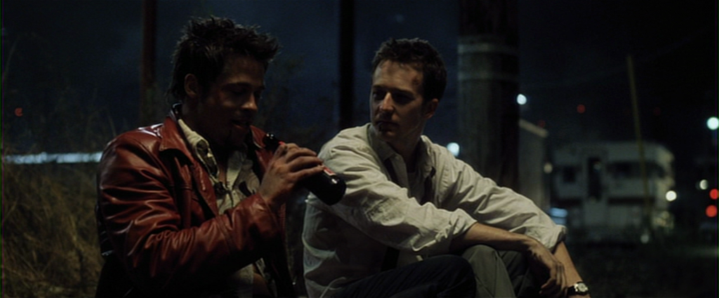

by using colour this way, the spectator can easily interpret the mood and tone conveyed without any additions as ‘colour effects how we feel and how we behave’ and is ‘rarely recognised by the audience’ being helpful to subliminally tell the story. Filmmakers are able to ‘manipulate audience’s moods and emotions quite simply through orchestrating colour’. Red can activate ‘aggression, anxiety or compulsion’, Stanley Kubrick’s The Shining uses red doors in the elevator scene for a heightened anticipation of the ‘blood river’. Yellow has two sides, one being related to happiness, life and energy and on the other being ‘visually aggressive’ and a ‘cautionary colour’ related to stress and a ‘signal for obsession’. Robert De Niro’s character in Taxi Driver is driving a yellow taxi throughout the film, a visual glimpse into his sanity.
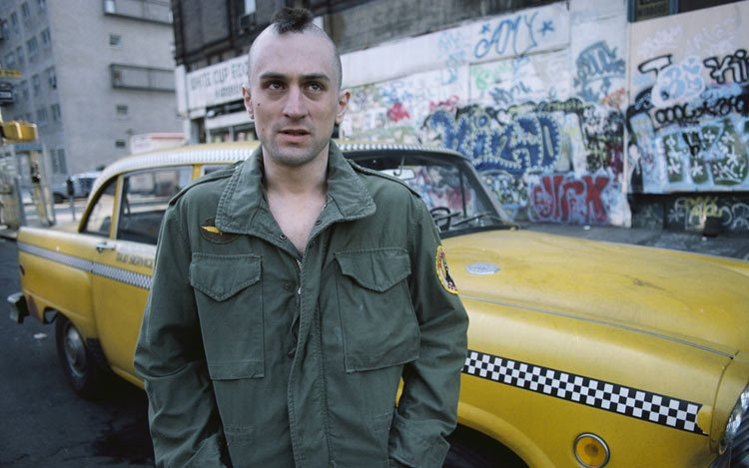
As yellow can be taken both ways, it will be perfect for the genre of dark comedy as its subjectiveness can be interpretive, dependant on the spectator’s opinion which can further the confusion thus adding comedic value. Blue, ‘passive, introspective and melancholic’ used in films to display passivity and calm. Nicolas Winding Refn’s Drive acquires a slow, paced narrative and character supported by blue tones and conflicting relationship dynamic with warm oranges. I intend to use colour in my film, to display the character’s emotion and alter the spectator’s perception of the moment.

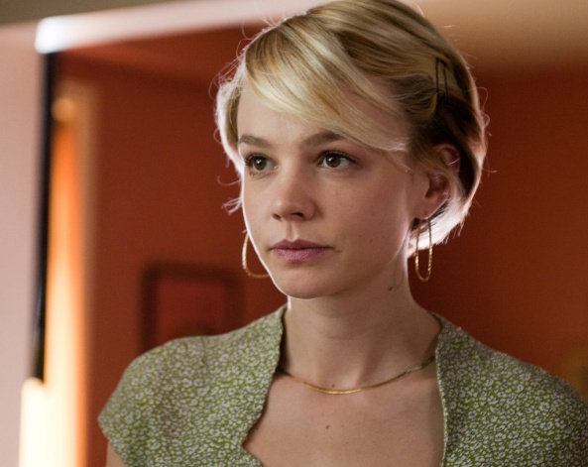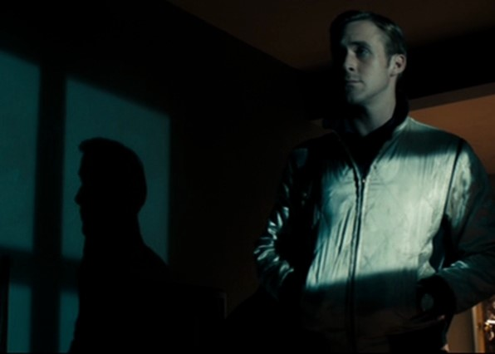

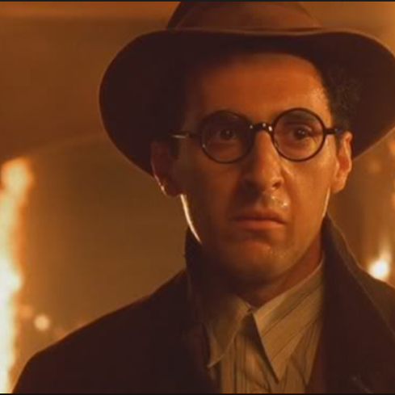
A social realism, of course mimics real life almost like a documentary. There is a fictional story to tell but often the intention is to grab the spectator by relation to their own life therefore, the colour palette is restricting and monotone like ‘Sweet Sixteen’ or ‘Wasp’. Seeing as ‘colours enhance an individual's visual memory’, films that do not bring in a lot of colour, for me are not as memorable and do not elicit the same emotional connection I may have. For example, ‘Lady Bird’ leans toward a warm, orange tint which relates to ‘youth and sociability’ (which are also both major themes in the film) thus my remembrance of the film is fond as the colour ‘supports a warm and welcoming congeniality’ However, this all depends on the directors intention as the same colours can be used for different responses depending on context and accompanying conventions like character placement, setting, music, or lighting. Barton Fink uses orange throughout, however instead of the response of warmth, there is an heir of nausea as the protagonist’s surroundings are falling apart, dark and claustrophobic. The orange externalises the feeling of sweltering heat which is also visually exposed at the climax through the use of flames.
This could be a use of foreshadowing as orange is constantly overwhelming the screen therefore, the release of colour at the end through the blue sky and ocean is ever more satisfying. As the viewer is subconsciously affected and left with a certain feeling at the end of the film, I would like to explore the same possible overwhelming use of colour to subconsciously affect the viewer and prolong a certain feeling of satisfaction or dissatisfaction at the end of the film by using certain objects, clothing or reflection of colour from light bounce.

SOUND
Sound is divided into two sections, diegetic and non-diegetic, diegetic coming from the greek diegesis meaning ‘narration or recital’. Before it was named such, the differentiation between what is visible on screen and the audio soundtrack was first named actual and commentative, from the influential Karel Reisz and Gavin Miller in their book The Technique of Film Editing (1968). Sound track ‘can clarify image events, contradict them or render them ambiguous’ while also creating expectations. A door creaking off screen builds an expectation of seeing the source in the next shot, however a director can exploit this technique and create suspense by concealing the source and by ‘choosing certain sounds, filmmakers guide our perception of the image’.
Sound in cinema is categorised in three types, speech, music and noise (or sound effects). What I am most interested in is the unexpected and uneasy use of sound. One of my main inspirations introducing me to this possibility was The Coen Brothers Barton Fink (1991). The film classifies as a dark comedy, using eccentric characters, lingering shots of reactions and dark narrative focus. The Coen’s also take advantage of the unnerving use of heightened, usually unnoticed noises of everyday life. Some specific scenes come to mind, the squeaking sounds of leather as Barton’s publisher shifts in his seat, the squelch of wallpaper paste as it loosens, or the bouncing springs with each movement emitted from the low-cost, budget bed. I will use foley to reproduce everyday sound effects and record with a mic to sync with the visuals.

The use of heightened sound for a character based experience is also seen in other films for the same effect. Mother! directed by Darron Aronofsky uses the same direction for unsettling tone through the absence of a score so the viewer can’t fall back on it as an emotional cue. I am considering using this method to bewilder the viewers emotion to create an aggravating outcome in order to develop a sense of questioning. However, short films I have watched such as Uneventful Published by Imperial College Tv occupies a sudden escalation of narrative development through murder with the accompaniment of slow, romantic music obviously neglecting the intense situation leaving the viewer undisturbed and able to find it humorous. To make the events seem instantaneous, they use quick cuts of action so the viewer is never able to fully immerse themselves and empathise with the character, making it easier to laugh at the situation as an outsider. The short film Counselling published by iThentic does not use music to direct the viewers feelings, the unaffected and ‘normal’ behaviour despite the innapropriate extreme of holding someone hostage is comedic in itself as the film isn’t trying to create a sympathetic character while also using an upbeat track when rolling the credits to leave the viewer with a sense of comedy. Both approaches are effective and I plan to experiment with both in post-production.

FOLEY

I would like to use Foley as a way to heighten certain movements for better audio quality and to create unease. I can record in a quiet room with an absorbing fabric behind me such as a blanket or I can use the recording studio in college depending on times and booking. Some possibilities to use are footsteps, made by mimicking the steps on the appropriate surface (tile, wood, leaves) while also depending on the type of shoe she will be wearing such as heels or flats, to recreate rustling of clothing I can record the movements with the suitable type of fabric. I will also record narration the same way with a possible addition of breathing in some scenes.
All of these are recorded by watching the footage in order to sync the audio; I plan to test different objects to create the desired sound one filmed.

MARY HARRON

As a female filmmaker myself, learning about Mary Harron’s director style and perspective on women will develop my own auteur style as many mainstream films are directed by males thus typically offer a male point of view, usually overlooked by the audience.
Being a female, Mary Harron has offered a different viewpoint with narrative focus and development of characters which I plan to incorporate and consider for my own project.
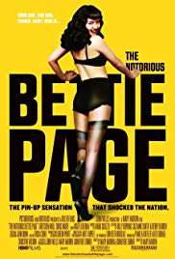
Mary Harron has created ‘feminist’ films bringing a ‘female perspective’, in particular Patrick Bateman in American Psycho. From ‘2002-2012 only 4.4% of filmmakers were female’, ‘a lot of men were disappointed’ in Harron’s film The Notorious Bettie Page with ‘anger among critics’ that she had not made a ‘sexy movie’.

Without providing the ‘male experience’ and focusing more on ‘the lives of women’ and ‘women’s histories’, Harron can be classified as a feminist filmmaker despite ‘rarely being described as one’. American Psycho would have been different if ‘shot by a man’ delving into the perspectives of the women, lingering on female expressions and focusing on the ‘ugly underbelly of the male ego’. The antihero is usually displayed as a ‘sort of cool, deranged version of the worst kind of wish fulfillment’, (Walter White, Tyler Durden) Harron’s version ‘rightfully sees Bateman as pathetic’ exploiting the ‘worst aspects of the male id’. This exploitation through a female’s perspective is less of a focus on murder than it is a ‘satire about how men compete with each other’, finding ‘humour in the emotional nihilism of these characters’. I like this idea, crafting a satirical character without morals and ‘existential unease’ while openly displaying their unlikeable, petty characteristics. With my focus being on a female, the male aspects that create American Psycho will be replaced with female downfalls, exploiting the need to look attractive or be liked.
While she uses the stylistic conventions of genre, none of her films ‘function as genre films’, causing anger with people expecting something ‘straightforward’. As with American Psycho, the viewer is confused whether to side with the protagonist as he is immature and insecure, however extremely violent, the use of upbeat music disrupts the serious tone of graphic scenes of violence and the blatant psychopathic tendencies nobody seems to notice.

AMERICAN PSYCHO

Directed by Mary Harron and adapted from Bret Easton Ellis’s controversial novel, American Psycho displays its feminist approach as it focuses on the ’critique of male behaviour’ exploiting the way men perceive women and treat them. A ‘novel about blood lust, into a movie about men’s vanity’ bringing humour to the ‘crazy society’ that is so obsessed with the ‘minuscules of status’.

The film was controversial having the extreme violence, explicit sex scenes and misogynistic tone. At the time of release, it was degraded only to these attributes, the satirical value of an ‘assessment of modern masculinity run amok’ was not recognised. Although receiving the rating ‘R’ and dealing with gruesome topics, comedy and exploitation of male desires separates American Psycho from other slasher films. The mixing of genre elements from horror and comedy is seen by the use of music and abruptness ‘from a social satire to something horrifying and upsetting’. Being introduced to the main character through a rigorous morning routine only to immediately transition to his bland expression as he glides through the office over ‘I’m walking on sunshine’ introducing the misleading comedic tone the film will inhabit. The upbeat music of ‘It’s Hip to be Square’ accompanies Bateman as blood sprays across his face and hurdles an axe off screen in the direction of his accomplice. Even without the explicit action being shown, the implication delivers the same if not more of a disturbing reaction in the viewer as we watch only his expression of sheer psychopathy.

Again, the severity of the situation is comedically overshadowed by music and smirk laid across his face. This adds a character dimension of pure insanity and indifference that I could employ for the character in my project by a visual display of laughter.

Bateman’s constant need for one-upmanship creates an insecure and unlikeable protagonist intentionally directing the audience to ‘laugh at him, not with him’ being executed through his immature narration; ’I have a better haircut’, ‘I can’t believe that Brice prefers Van Patten’s card to mine’ - this scene at 18:20 - 20:15 is especially telling of Bateman’s character. He reacts in ‘such a ridiculous manner’ displayed by extreme close-ups, sweating coupled with a disturbed expression and heightened by the use of intense sound overlays and ominous music as each business card is unveiled; a satirical portrait of the over concerned 80’s businessman. The use of intense music makes the scene parodic as the focus is petty and unimportant.

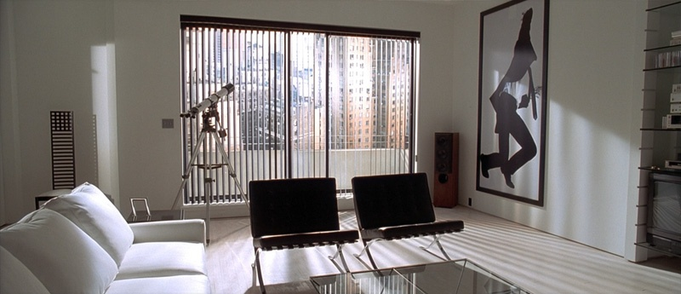
The colour is monotonous and restricted to a dull, lifeless palette making any vivid accents eye catching and out of place. However, red is prominent throughout in small doses, red streaks across the screen are shown at the start of the film through a close up montage of preparing food foreshadowing the violence to come, again at 9:00, Bateman’s fiancé (Reese Witherspoon) is wearing red, an embodiment and reflection of his thoughts of murdering women. Batemans’ surroundings are generally bland, sterile and boring, externalising the feeling of mundane everyday life he endures and ‘paint[s] Bateman’s reality as one-dimensional and hollow’.
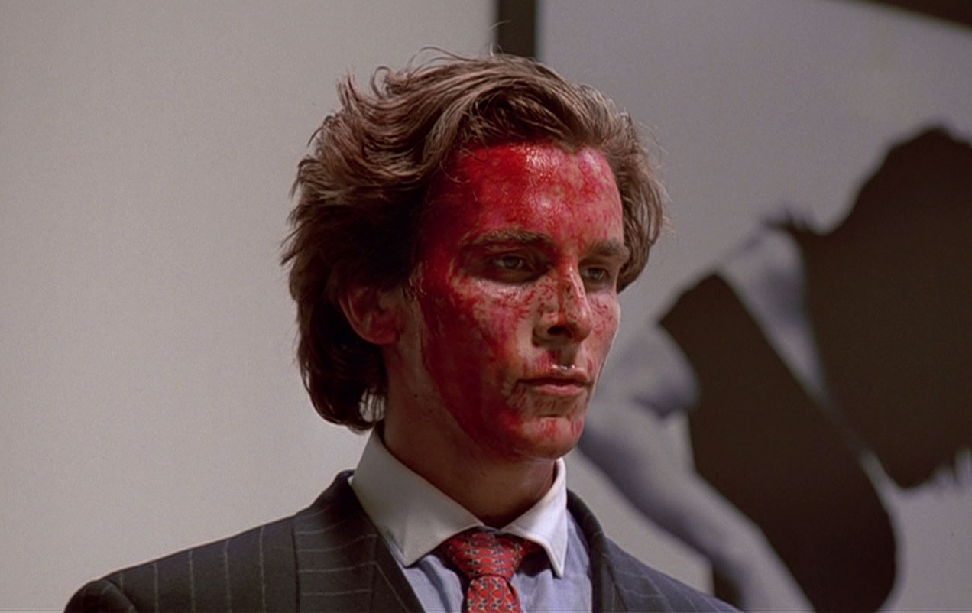
When red blood splatters across his face at 29:00, his slow, tame character is suddenly a crazed monster teeming with aggression, an unrecognised participation of excitement is induced in the viewer as the vivid red creates a much needed splash of colour in such a tired, drab environment making the subject seem thrilling rather than upsetting.

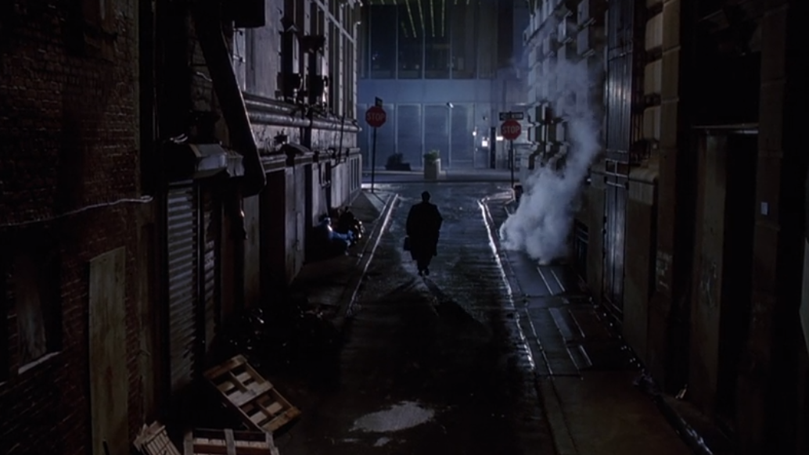
Menacing orchestral music used by older classic horror films like Psycho or Repulsion is, in my opinion, ironically employed throughout to enhance a sense of parody to the genre. Patrick Bateman walks toward the empty street enveloped in his trailing trench coat accompanied with a dramatic score giving the image of heroism despite murdering a homeless man and his dog at 22:20.
The extreme behaviour induced by such petty competition deriving from the previous business card scene, is farcical and unnecessary which furthers the comedic effectiveness of the scene. Again at 30:00, after murdering his associate ’Paul Allen’ the intense dramatic music returns accompanied by the frantic explanation of his actions as he slowly unravels. The intensity created before-hand makes the scene of Bateman’s impression of Paul Allen that follows ever more comical as it’s unexpected and mockful. To administer the same ironic tone, I would like to experiment using similar overdramatic music.
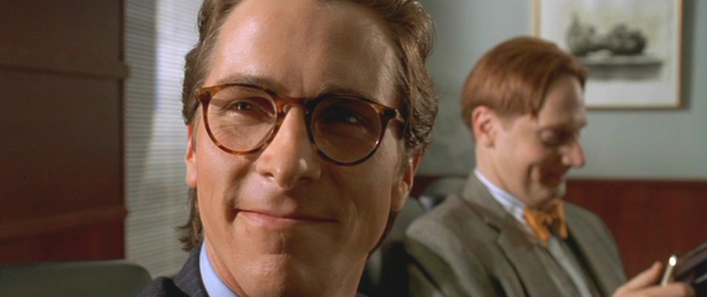
Center frames are used frequently; often close-up to display Bateman’s self-obsession and importance within the film, like his narration, the visual filling of his character in the screen externalizes the narcissistic perception of himself.

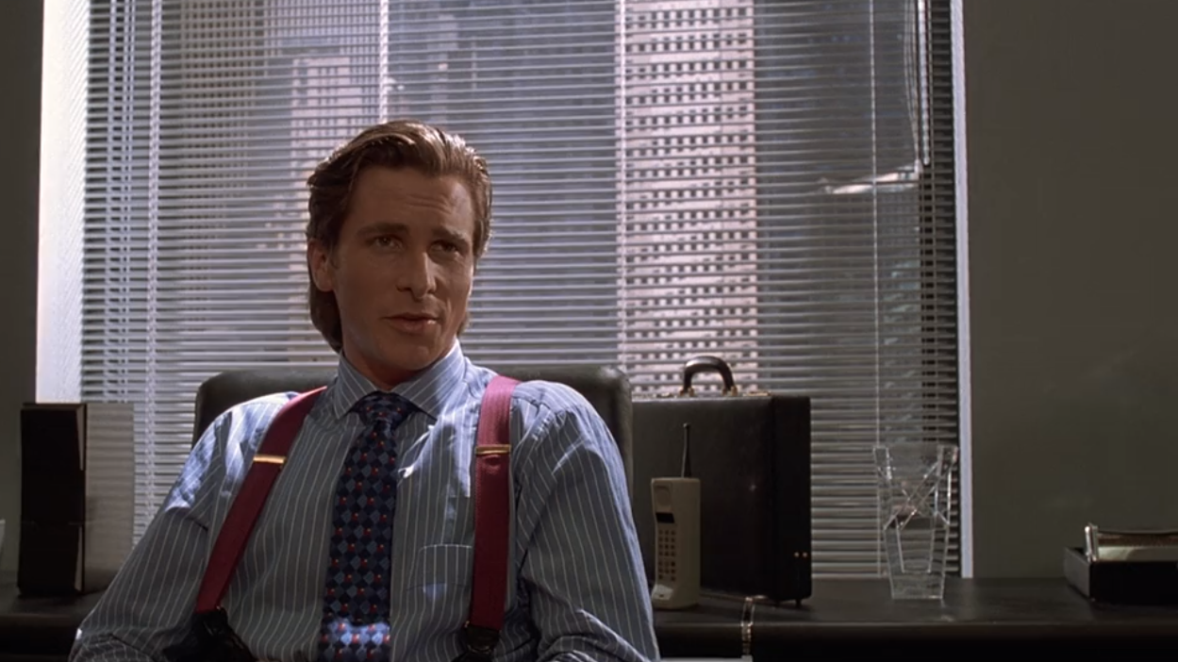
Each frame is perfectly proportioned, balanced and follows a pattern of straight, neat lines. Venetian blinds create symmetry and directional importance as well as maintaining a neat, tidy background juxtaposing Bateman’s inner conflict and possible reason for his psychopathy as it becomes overwhelming; the lack of colour supports this feeling of restlessness as it factors in the majority of shots. It could also be an externalized feeling of Batemans attempt to fit in.

Power is shifted when Detective Kimball encounters Patrick, he is no longer center frame, overpowered by Kimball now taking this place. - ‘Kimball sits down and crosses his legs with a self-assurance that makes Bateman so nervous’ This excerpt from the screenplay translates to the screen by use of compositional cinematography and shifting the character importance by use of center frame which is not as noticeable as the action of anxiety through acting but equally supports the shift in dynamic. By utilizing cinematography to visually explain the inner conflict of a character, the implication creates more dimension as it subliminally relays the information thus developing a stronger understanding for the viewer.

Patrick Bateman believes he is a superior human being, through his high rise, meticulously decorated apartment, obsessive body awareness, and flaunting of wealth. He believes people are interested in his opinions and hold him in high esteem, however this false perception is evident from the scene at 12:20, Patrick delivers a speech relaying his views (again, center frame) to a table full of people, only to be responded to with a choke on water as one laughs at his statement. Bateman is completely oblivious, relating to his sociopathic tendencies of ego-centrism. The viewer is well aware of this self-obsession as the director visually suggests this through the character looking in mirrors, narration of every thought mimicking audio of a commercial (clear, undisrupted, precise) as if advertising his life, and pompous, over-confident acting. Exposing these qualities of his character could relate to the female perspective, acknowledging the mask of charisma and confidence that men take on afraid to face the insecurity they inhabit to be accepted and liked. A male perspective’s goal may be to create a wholly likeable character as they may themselves not acknowledge the balance of good and bad in the male ego.

Dialogue is an important aspect of what creates the comedic value. The short and impatient responses from Bateman reflect in the screenplay and is easily visualised without the moving image.
OWEN
Hey, Halberstam?

BATEMAN
Yes, Owen?

OWEN
Why are there copies of the Style section all over
the place? Do you have a dog? A chow or something?

BATEMAN
No, Owen.

OWEN
(Confused)
Is that a raincoat?

BATEMAN
Yes, it is.
By using short, snappy dialogue I can develop my own character’s characteristics of superiority and indifference to the receiver.

QUANTITATIVE

All research found at: https://www.boxofficemojo.com/movies/?id

I have compiled a list of some popular dark comedies to better understand the success of the genre and possible contributing influences.

Barton Fink (1991) had a budget of 9 million, receiving only 6.2 million from box office classified as a black comedy, thriller, drama and mystery. The non profitable outcome of the film could be due to the casting of John Turturro as lead who was not as established at the time and the rating ‘R’ limiting audience numbers.

Fight Club (1999) recieved 100.9 million with a budget of 63 million, classifying as an action, drama and black comedy. Starring Brad Pitt and Edward Norton, these stars contribute to the success as well as attracting a larger crowd familiar with the novel.

American Psycho (2000) gained 34.3 million with a budget of 8 million. Although being controversial among critics and audiences, it did well as it was based on the novel.

Shaun of The Dead (2004) budgeted at 6.1 million with box office numbers of 30 million, of the three it is the most profitable. Possibly because of the stars Simon Pegg and Nick Frost, known for their comedic background therefore receiving an expansive audience.

Hot Fuzz (2007) only budgeted at 8 million and receiving a high profit of 80.7 million. Edgar Wright directed both films and casted the same actors as Shaun of The Dead which developed an audience who were familiar with the director’s style and gained more attention.

Birdman (2014) gained 103.2 million with a budget of 18 million. Micheal Keaton, Emma Stone, Edward Norton and Zach Galifianakis all star in this black comedy which gains much attention in audiences.

Three Billboards Outside Ebbing Missouri (2017) also has the advantage of big stars, Frances McDormand, Peter Dinklage and Woody Harrelson. Making 159.2 million with a budget of 13 million. Winning and being nominated for many awards, it has gained high critic reviews thus a higher chance of audience participation in theatres.

Dix, A. (2016). Beginning Film Studies. 2nd ed. Manchester: Manchester University Press, p.141.
Dix, A. (2016). Beginning Film Studies. 2nd ed. Manchester: Manchester University Press, p.141.
Bordwell, D. and Thompson, K. (2001). Film Art : An Introduction. 6th ed. Europe: McGraw-Hill Education, p.96.
Dix. Beginning Film Studies, p.140.
Hoffman, M. (2014). The Comedy Genre: Film’s First Cinematic Movement. [online] Cinemablography. Available at: http://www.cinemablography.org/blog/the-comedy-genre-films-first-cinematic-movement [Accessed 20 Mar. 2019].
Ibid.
Ibid.
Wigley, S. (2019). 10 great screwball comedy films. [online] British Film Institute. Available at: https://www.bfi.org.uk/news-opinion/news-bfi/lists/10-great-screwball-comedies [Accessed 22 Mar. 2019].
Hoffman. The Comedy Genre: Film’s First Cinematic Movement. [online] Cinemablography. Available at: http://www.cinemablography.org/blog/the-comedy-genre-films-first-cinematic-movement [Accessed 20 Mar. 2019].
Hoffman, M. (2014). The Comedy Genre: Film’s First Cinematic Movement. [online] Cinemablography. Available at: http://www.cinemablography.org/blog/the-comedy-genre-films-first-cinematic-movement [Accessed 20 Mar. 2019].
Miyamoto, K. (2016). 4 Reasons Why Screenwriters Should Break the Fourth Wall - ScreenCraft. [online] ScreenCraft. Available at: https://screencraft.org/2016/03/31/4-reasons-why-screenwriters-should-break-the-fourth-wall/ [Accessed 26 Mar. 2019].
I Like Things That Look Like Mistakes. (2013). The Men Who Weren’t There: The Unreliable Narrator and His Effect on Audience’s Perception of Reality and Truth in Neo-Noir. [online] Available at: https://moviescene.wordpress.com/2013/07/09/the-men-who-werent-there-the-unreliable-narrator-and-his-effect-on-audiences-perception-of-reality-and-truth-in-neo-noir/ [Accessed 27 Mar. 2019].
I Like Things That Look Like Mistakes. (2013). The Men Who Weren’t There: The Unreliable Narrator and His Effect on Audience’s Perception of Reality and Truth in Neo-Noir. [online] Available at: https://moviescene.wordpress.com/2013/07/09/the-men-who-werent-there-the-unreliable-narrator-and-his-effect-on-audiences-perception-of-reality-and-truth-in-neo-noir/ [Accessed 27 Mar. 2019].
I Like Things That Look Like Mistakes. (2013). The Men Who Weren’t There: The Unreliable Narrator and His Effect on Audience’s Perception of Reality and Truth in Neo-Noir. [online] Available at: https://moviescene.wordpress.com/2013/07/09/the-men-who-werent-there-the-unreliable-narrator-and-his-effect-on-audiences-perception-of-reality-and-truth-in-neo-noir/ [Accessed 27 Mar. 2019].
Vasiliauskus, M. (2018). Mastering the Movie Color Palette: How David Fincher Uses Color in Film. [online] StudioBinder. Available at: https://www.studiobinder.com/blog/movie-color-palette-david-fincher/ [Accessed 25 Mar. 2019].
Bellantoni, P. (2005). If It's Purple, Someone's Gonna Die: The Power of Color in Visual Storytelling. Burlington: Focal Press, p.xxviii.
Sampson, R. (2019). The Power Of Colour In Film: Storytelling Through Chromatics. [online] Film Inquiry. Available at: https://www.filminquiry.com/power-colour-storytelling/ [Accessed 26 Mar. 2019].
Bellantoni, P. (2005). If It's Purple, Someone's Gonna Die: The Power of Color in Visual Storytelling. Burlington: Focal Press, Chapter 1, p.1.
Bellantoni, P. (2005). If It's Purple, Someone's Gonna Die: The Power of Color in Visual Storytelling. Burlington: Focal Press, Chapter 2, p.1.
Bellantoni, P. (2005). If It's Purple, Someone's Gonna Die: The Power of Color in Visual Storytelling. Burlington: Focal Press, Chapter 3, p.1.
Mone, G. (2002). Color Images More Memorable Than Black and White. [online] Scientific American. Available at: https://www.scientificamerican.com/article/color-images-more-memorab/ [Accessed 26 Mar. 2019].
Digital Synopsis. (2018). How Filmmakers Use Colors To Set The Mood Of A Film. [online] Available at: https://digitalsynopsis.com/design/film-movies-color-psychology/ [Accessed 4 Apr. 2019].
Bellantoni, P. (2005). If It's Purple, Someone's Gonna Die: The Power of Color in Visual Storytelling. Burlington: Focal Press, Chapter 4, p.1.
Dix, A. (2016). Beginning Film Studies. 2nd ed. Manchester: Manchester University Press, p.87.
Bordwell, D. and Thompson, K. (2001). Film Art : An Introduction. 6th ed. Europe: McGraw-Hill Education, p.292.
Bordwell, D. and Thompson, K. (2001). Film Art : An Introduction. 6th ed. Europe: McGraw-Hill Education, p.292.
YouTube. (2015). Uneventful - A Dark Comedy Short Film (2015). [online] Available at: https://www.youtube.com/watch?v=K66ac7rmUmM&ab_channel=ImperialCollegeTV [Accessed 2 Apr. 2019].
YouTube. (2013). Dark Comedy Short: Counselling. [online] Available at: https://www.youtube.com/watch?v=0Y0owfoFlM8&ab_channel=iThentic [Accessed 3 Apr. 2019].
Gross, A. (2014). An Interview with Mary Harron. [online] Believer Magazine. Available at: https://believermag.com/an-interview-with-mary-harron/ [Accessed 29 Mar. 2019].
Gross, A. (2014). An Interview with Mary Harron. [online] Believer Magazine. Available at: https://believermag.com/an-interview-with-mary-harron/ [Accessed 29 Mar. 2019].
Gross, A. (2014). An Interview with Mary Harron. [online] Believer Magazine. Available at: https://believermag.com/an-interview-with-mary-harron/ [Accessed 29 Mar. 2019].
Bastién, A. (2016). The Female Gaze of ‘American Psycho’: How Mary Harron Made Fantasy Into Timeless Satire. [online] Villagevoice.com. Available at: https://www.villagevoice.com/2016/06/07/the-female-gaze-of-american-psycho-how-mary-harron-made-fantasy-into-timeless-satire/ [Accessed 29 Mar. 2019].
Bastién, A. (2016). The Female Gaze of ‘American Psycho’: How Mary Harron Made Fantasy Into Timeless Satire. [online] Villagevoice.com. Available at: https://www.villagevoice.com/2016/06/07/the-female-gaze-of-american-psycho-how-mary-harron-made-fantasy-into-timeless-satire/ [Accessed 29 Mar. 2019].
Bastién, A. (2016). The Female Gaze of ‘American Psycho’: How Mary Harron Made Fantasy Into Timeless Satire. [online] Villagevoice.com. Available at: https://www.villagevoice.com/2016/06/07/the-female-gaze-of-american-psycho-how-mary-harron-made-fantasy-into-timeless-satire/ [Accessed 29 Mar. 2019].
Bastién, A. (2016). The Female Gaze of ‘American Psycho’: How Mary Harron Made Fantasy Into Timeless Satire. [online] Villagevoice.com. Available at: https://www.villagevoice.com/2016/06/07/the-female-gaze-of-american-psycho-how-mary-harron-made-fantasy-into-timeless-satire/ [Accessed 29 Mar. 2019].
Gross, A. (2014). An Interview with Mary Harron. [online] Believer Magazine. Available at: https://believermag.com/an-interview-with-mary-harron/ [Accessed 29 Mar. 2019].
Ebert, R. (2000). American Psycho Movie Review & Film Summary (2000) | Roger Ebert. [online] Rogerebert.com. Available at: https://www.rogerebert.com/reviews/american-psycho-2000 [Accessed 30 Mar. 2019].
BaleheadsBlog. (2013). Christian Bale Talks American Psycho To Charlie Rose | Part 1/2. [online] Available at: https://www.youtube.com/watch?v=adGtFrHNnhc&ab_channel=BaleheadsBlog [Accessed 30 Mar. 2019].
Youtube. (2013). Christian Bale Talks American Psycho To Charlie Rose | Part 1/2. [online] Available at: https://www.youtube.com/watch?v=adGtFrHNnhc&ab_channel=BaleheadsBlog [Accessed 30 Mar. 2019].
Flores, B. (2015). Film Cinematography Appreciation: American Psycho. [online] The Art of Cinematography. Available at: https://theartofcinematography.wordpress.com/2015/11/15/film-cinematography-appreciation-american-psycho/ [Accessed 1 Apr. 2019].

